**MAWLANA BHASHANI SCIENCE AND TECHNOLOGY UNIVERSITY**

SANTOSH, TANGAIL-1902



DEPARTMENT OF INFORMATION AND COMMUNICATION TECHNOLOGY

**Course Title: Digital Logic Design Lab**

**Course Code: ICT-2104**

**Lab Report on:** Implementation of a Combinational Circuit

**Lab Report No: 02**

|  |  |
| --- | --- |
| Submitted By | Submitted To |
| Name: Kuldip Saha Mugdha  ID: IT22018  2nd Year, 1st Semester  Session: 2021-2022  Dept. of ICT, MBSTU | Dr. Muhammad Shahin Uddin  Professor  DEPARTMENT OF INFORMATION AND COMMUNICATION TECHNOLOGY  MAWLANA BHASHANI SCIENCE AND TECHNOLOGY UNIVERSITY |

**Date of Performance:**

**Date of Submission:**

**Experiment No:** 02

**Experiment Name:** Implementation of a Combinational Circuit

**Objective:** To design and implement a combinational logic circuit based on the provided diagram and verify its behavior using the corrected Boolean expression

Q = YZ + (Y’Z + YZ’) X

**Materials Required:**

* Breadboard
* Power supply (5V DC)
* Connecting wires
* Logic gate ICs:
* AND gate (IC 7408)
* OR gate (IC 7432)
* NOT gate (IC 7404)
* LEDs (to observe outputs)
* Resistors (220Ω)
* Multimeter (optional)
* Three switches for inputs (x, y, z)

**Procedure:**

**1. Combinational Circuit Overview:**

- A combinational circuit is one where the output is determined by the present inputs using logic gates without memory elements.

**2. Circuit Setup:**

- Set up the ICs (AND, OR, and NOT gates) on the breadboard.

- Connect the power supply: pin 7 of each IC to ground and pin 14 to +5V.

- Use input switches for variables x, y, and z.

- Connect the gates according to the circuit diagram.

- Connect the output of the circuit to an LED with a resistor to observe the result.

- Ensure all connections are verified using a multimeter if necessary.

**3. Operation:**

- Test the circuit with different combinations of the inputs (x, y, z).

- Record the outputs for all possible input combinations to form the truth table.

**Diagram:**

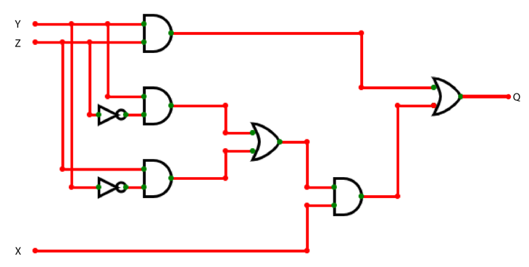

**Truth Table:**

|  |  |  |  |
| --- | --- | --- | --- |
| **X** | **Y** | **Z** | **Q** |
| 0 | 0 | 0 | 0 |
| 0 | 0 | 1 | 0 |
| 0 | 1 | 0 | 0 |
| 0 | 1 | 1 | 1 |
| 1 | 0 | 0 | 0 |
| 1 | 0 | 1 | 1 |
| 1 | 1 | 0 | 1 |
| 1 | 1 | 1 | 1 |

**Discussion:**

The combinational circuit follows the Boolean equation:

Q = YZ + (Y’Z + YZ’) X

The truth table validates the output for each input combination. The circuit effectively produces a high output when either both y and z are high, or when an XOR condition between y and z is met and x is high.